# Wrapper Class in Salesforce

a collection of different Salesforce [data types](https://intellipaat.com/blog/tutorial/salesforce-tutorial/different-types-data-types-field-types/). In Salesforce, you can combine multiple data types and utilize them for various purposes.

# MVC Architecture

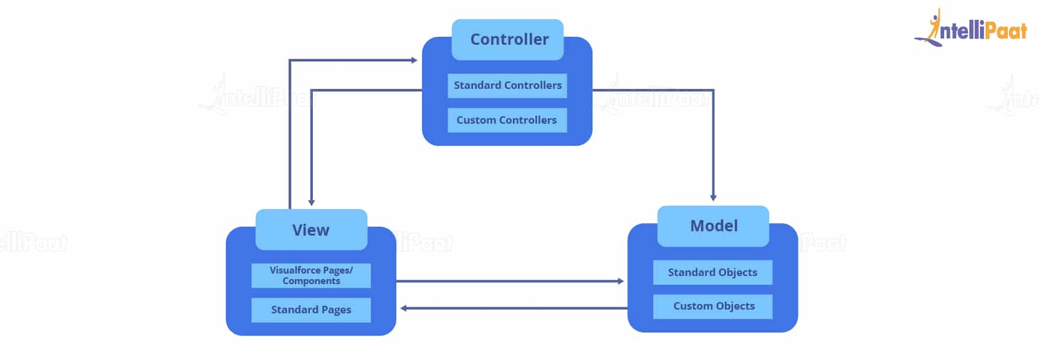

Controllers are responsible for modeling and viewing objects, components, and pages.

# How the requirement comes up in your project?

# Working flow and process of your project?

# Batch Apex?

# Opportunity in SF?

# Quick action in SF?

# What was the recent business requirements (user story) you worked, and logic applied for the same?

# SOQL and SOSL and uses criteria for both?

# aura method tag and use of that?

# Process builder and Workflow, uses criteria for both?

# Asset in SF?

# Flow in SF?

# controller constructor salesforce?

# salesforce controller extension constructor?

# How many trailhead bedags earned?

# CIAM in Salesforce?

# Diff b/w Sprint and Iteration?

# Diff b/w Scrum and SAFE?

# definition of done (DoD) & ready (DoR) agile?

# planning poker?

# user stories acceptance criteria?